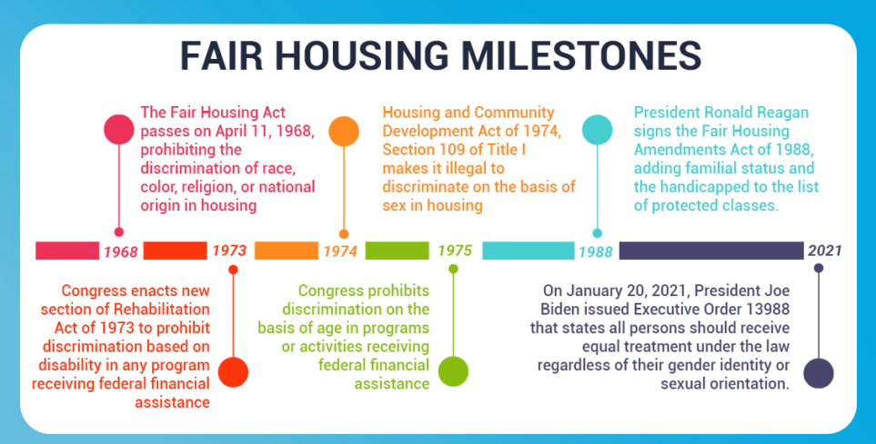

The Fair Housing Act (FHA) of 1968 was passed to prohibit the discrimination of race, color, religion, or national origin in the sale, rental or financing of housing. It didn’t stop there though, please see the above milestone chart to see the changes that have been made since 1968. The FHA covers both private and public housing.
Did you know the FHA may be used to request a Reasonable Accommodation and Reasonable Modification request for those individuals with a disability?
Under the FHA, a disability is defined as a person with a physical or mental impairment which substantially limits one or more of such person’s major life activities, a record of having such impairment or being regarded as having such impairment is disabled under both the FHA and the Rehabilitation Act.
Major Life activities include walking, talking, hearing, seeing, breathing, learning, manual tasks, and caring for oneself.

What is a Reasonable Accommodation? It is a change, adjustment or exception to a rule, policy, procedure, or service.
Example of Accommodation Requests:
      - Allowing a Service Animal or Emotional Support Animal.
      - Reserved Parking space
      - Live-in Aide
      - Unit Transfer
      - Pay Rent Late

What is a Reasonable Modification? It is a physical change to the interior of the resident’s apartment or the common use areas.
Examples of a modification:
      - Installing Grab Bars
      - Widening a doorway
      - Installing a Ramp
      - Installing or Removing Carpet

Reach out to the Fair Housing Department for more information on Reasonable Accommodation and Reasonable Modifications at FairHousing@royalamerican.com.

